Title page

Price Discrimination in Two-Sided Markets

Kai Zhangª, Weiqi Liu^{b}
- Institute of Management and Decision, Shanxi University, Taiyuan, PR China, e-Mail: zhangkai@sxu.edu.cn
- Institute of Management and Decision, Shanxi University, Taiyuan, PR China, e-Mail: liuwq@sxu.edu.cn

*Corresponding author:

Kai ZHANG

E-mail: zhangkai@sxu.edu.cn

Tel: +86 (0)137 3402 4033
Address: Institute of Management and Decision, Shanxi University; No.92 Wucheng Road, Taiyuan City, Shanxi Province, PR China; Zip code: 030006
Price Discrimination in Two-Sided Markets

Abstract The use of a price discrimination strategy is an important tool in competition which can hurt firms and benefit consumers in one-sided market, however, its primary goal is to attract more agents or increase profits in two-sided markets. Here, the performance of a second-degree price discrimination strategy in the context of duopoly two-sided platforms is analyzed. Two exogenous variables, which include the discount rate and the price discrimination threshold, are used in order to to examine whether the price discrimination strategy can help two-sided platforms achieve their objective: maximizing their market value. Three cases are considered and we demonstrate that the price discrimination strategy cannot simultaneously attract more agents and increase profits; a lower price discrimination threshold cannot ensure bigger markets shares; a higher discount rate is detrimental to the profit of a platform, however, is good for its market shares. Moreover, price discrimination price increases the competition.

Keywords price discrimination; cross-network externality; two-sided market; gaming
1. Introduction
Typical two-sided markets (no distinction is made here between two-sided platforms and two-sided markets (Schmalensee and Evans, 2007)) such as PC operation systems, payment cards, shopping malls, electric commerce platforms, videogames, newspapers, network televisions, real estate agents, dating services, and nightclubs have attracted a significant amount of attention, especially after the publication of the following seminal papers by Armstrong (2006a), Caillaud and Jullien (2003), Rochet and Tirole (2003) and Schiff (2003). In such markets, two or more unique groups of agents interact with each other via platforms, called two-sided (multi-sided) platforms. The utility for an agent in one group that participates in a platform is dependent upon the number of participating agents in another group in the same platform. The significant difference between two-sided markets and orthodox one-sided markets is the failure of the Coase theorem, which means that agents on both sides are unable to internalize all of the externalities (Rochet and Tirole, 2004). The fundamental problem in two-sided markets is how to get different groups around the platform by setting-up price structure.
A common strategy utilized in two sided markets to either attract more consumers or increase profits is price discrimination, although under the Robinson-Patman Act in the United States, this is illegal in the intermediate goods markets (Liu and Serfes, 2008). One example of this is the two-part tariff charged by Dangdang, the fifth largest Business to Customer in China, and is broken down as follows: the total fee per month the usage feethe discount ratetrading volume, six levels of discount rates are in place in the context of a minimum monthly sales agreement, 0, 1.25%, 1.5%, 2.5%, 3% and 4%, and five levels are in place in the context of not having a minimum monthly sales agreement, 1.5%, 2%, 3%, 4% and 5%. Another example includes the annual fee of credit cards in China; the ICBC (Industrial & Commercial Bank of China), the BOC (Bank of China) and the ABOC (Agricultural Bank of China) both give consumers a free annual fee for the next year based on a five-time usage during the current year, whereas the BOC (Bank of Communications) and the CMB (China Merchants Bank) base their annual fee on a six-time usage, both the CEB (China Everbright Bank) and the CCB (China Construction Bank) bases their annual fee on a three-time usage. Further examples include the local Spanish TV industry (Gil and Riera-Crichton, 2011), broadband services and access-tiering (Weisman and Kulick, 2010), and the B2B and B2C websites (Caillaud and Jullien, 2003).
Conventional wisdom dictates that using the price discrimination strategy in one-sided markets is always detrimental to firms and beneficial to consumers (Armstrong, 2006b; Stole, 2003). However, this conclusion may not be applicable to two-sided markets (Liu and Serfes, 2008). Previous work has demonstrated that when the cross-group externality parameters are high enough, price discrimination leads to an increase in platform profits, hurts consumer welfare and softens competition (Liu and Serfes, 2008). Since research regarding two-sided markets is still in its infancy many unresolved issues still remain: (1) whether the beneficial claim to all agents of the price discrimination strategy in sales promotion holds true; (2) whether an increase in discount rates can attract more agents and increase profits; (3) whether the price discrimination strategy is always better than the no-price discrimination strategy; (4) how platforms correctly choose the price discrimination in order to accomplish different goals. Addressing each of these issues is the main goal of this paper.
This article expands upon prior work on price discrimination in the context of two-sided markets by introducing two exogenous variables, the discount rate and a price discrimination threshold. Our analysis differs from previous work in two additional ways: first, different goals can be achieved by platforms using the price discrimination strategy, such as either maximizing profits or maximizing market shares; second, we focus on how platforms can successfully implement price discrimination in a competitive environment. Our results demonstrate that a lower price discrimination threshold does not ensure an increase in markets shares due to a non-monotonic function; this result is in agreement with previous results (Liu and Serfes (2008)). Additionally, we also show that (1) a two-sided platform that uses a price discrimination strategy cannot simultaneously result in attracting more agents while increasing profits; (2) larger discount rates are bad for a platform’s profit, however, are good for its market shares; (3) the best response strategy for a platform aiming at maximizing their profit is to keep the same strategy intact when their opponent chooses a price discrimination strategy, otherwise it results in a smaller profit despite the discount rates; (4) the equilibrium profits are smaller in comparison to the profits in the case in which a no-price discrimination strategy was used, in other words discriminative pricing increases competition.
The organization of this paper is outlined as follows. Previous published literature on two-sided markets and price discrimination is discussed in Section 2. Our assumptions and model structure are outlined in Section 3. In section 4, we present a general analysis method and focus on three specific scenarios, numerical examples are also shown and we demonstrate the variety of applications. The main results and a discussion regarding the future direction of this area of research are summarized in section 5.

2. Literature reviews

2.1 Two-sided market
Two-sided markets, examples of which are shown in previous publications by Schmalensee and Evans (2007), Armstrong (2006a), Rochet and Tirole (2004), received little attention until one of the first formal analyses of two-sided business-payment cards was described in Baxter (1983). Additionally, the contributions made by David (1985), Katz and Shapiro (1985), Farrell and Saloner (1985) on network externalities have also had a significant impact on the research of two-sided markets. The first clear definition of a two sided market was given by Rochet and Tirole (2004); they define a market as being two-sided if any change in the price structure, or distribution, will affect the participation level or the number of interactions on the platform given that the total prices for both parties is held constant. Eight basic fallacies that arise from applying conventional wisdom regarding one-sided markets to a two-sided market setting are discussed in Wright (2004). The main characteristics of two-sided markets include cross network externalities (Armstrong, 2006a), winner takes all (Sun and Tse, 2007) and chicken and eggs (Caillaud and Jullien, 2003).
The main function of two-sided platforms is to reduce both the search and transaction costs (Caillaud and Jullien, 2003; Schiff, 2003), which is the same function as intermediation, by choosing input and output prices that will maximize profit (Spulber, 1996; Rust and Hall, 2003; Loertscher, 2007). However, two-sided platforms and intermediates are different, the latter being more focused on traditional intermediaries, also referred to as “make the market”, who buy and resell goods, whereas the former is influenced by the rising importance of “new economy” intermediaries, who connect buyers and sellers and provide matching, price discovery, certification, advertising and other informational services, usually without assuming complete control over the transactions (Hagiu and Jullien, 2007).
Until recently, the focus of the literature has been primarily on the effects of the relative magnitudes of indirect network externalities, demand elasticity and coordination (chicken and eggs) issues in platform pricing structure. The models used in the study of two-sided markets in the current literature can be broadly categorized as a usage model, a membership model or combinations of the two. The role of fixed membership costs and network externalities is emphasized in the usage model (e.g. Rochet and Tirole, 2003; Chakravorti and Roson, 2006; Guthrie and Wright, 2007). There is an emphasis on the externalities of the usage of the service in the membership model and it assumes linear (per-transaction) costs and pricing (Armstrong, 2006a; Armstrong and Wright, 2007). Research content is another important component of two-sided models, such as multi-homing or partial multi-homing (e.g., Roson, 2005; Gabszewicz and Wauthy, 2004; Doganoglu and Wright, 2006; ), ownership (e.g., Hagiu and Lee, 2011; Nocke and Peitz, 2007; Rochet and Tirole, 2003), profit or non-profit platform (e.g., Rochet and Tirole, 2003), open and closed platform (e.g., Economides and Katsamakas, 2006; Schiff, 2003), third-part content (Hagiu and Spulber, 2012), dynastic competition (Chen and Tse, 2007; Sun and Tse, 2007; Eriksson et al., 2008) and empirical work (e.g., Kaiser and Wright, 2005; Rysman, 2004).

2.2 Price discrimination
According to the seminal work of Pigou (1920), in order for price discrimination to occur in the traditional one-sided market theory, three conditions must be met: there is no re-sale between consumers, the willingness to pay varies among consumers, and there is a firm with market power that can implement price discrimination. A large body of literature regarding the study of both the theoretical and empirical nature of price discrimination in a one-sided market exists; however, the focus here is on the price discrimination in a two-sided market.
The development of the Internet and the rapid growth of sophisticated software tools are the two main reasons that price discrimination has been increasingly adopted as a common strategy, as mentioned by Liu and Serfes (2008). Nevertheless, little research exists regarding the price discrimination strategy and competition in the context of a two-sided market. The effect of group specific prices, i.e. third degree price discrimination, has been analyzed by Caillaud and Jullien (2003) and Armstrong (2006), whereas two-part tariffs were analyzed by Roche and Tirole (2003), Armstrong (2006a), and Reisinger (2010). First-degree price discrimination in a two-sided duopolistic market was examined by Liu and Serfes (2008). Although a few similarities exist between Liu and Serfes (2008) and our study, there are three main differences.
First, we study second-degree price discrimination. Agents on each side are charged differential prices according to the transaction time. This means that agents within a certain range have the same entrance price, which is more realistic due to the difficulty of first-degree price discrimination. Second, unlike what is done in Liu and Serfes (2008), where they only focused on the equilibrium price, price discount rates and discrimination thresholds play an important role in our model. Third, the model in Liu and Serfes (2008) focuses on the profitability and welfare implication of price discrimination, whereas our model concentrates on the successful implementation of price discrimination in different cases. Gil and Riera-Crichton (2011) expanded upon the model and results of LS through the addition of a simple extension for the monopoly case with no competition because of very high transportation costs. However, the main goal of their study was to revisit the empirical relation between price discrimination and competition in the Spanish local television sector and to show that price discrimination negatively correlates to the degree of product market competition. Another study carried out by Weisman and Kulick (2010), which was based on the Notice of Proposed Rulemaking (NPRM) released by the Federal Communications Commission (FCC), indicated that price discrimination is likely to increase the static efficiency in the market for broadband services because the market is two-sided and that it also promotes dynamic efficiency because it encourages innovation in the provision of broadband services. Several possible price discrimination strategies that may become available if network neutrality is abolished are presented in Economides (2008).
In summary, the intuitively significant features of price discrimination in two-sided markets is not fully explained in the current literature due to the focus on the competition and consumer’s welfare while neglecting the implementation of strategy. To gain insight regarding the new mechanism of price discrimination in two-sided markets, we consider the discount rate in the normal model and use transaction times as the price discrimination threshold. Also, by incorporating different goals of platforms, we present a general analysis method and compare the three special scenarios on price discrimination.

3. The model
The basis of our model is similar to the model found in Armstrong (2006a). We assume that there are duopolistic two-sided platforms that offer horizontal differentiated products, such as platforms like newspapers, credit cards, shopping centers, night clubs, and e-commences. Two platforms, denoted by k (k=1, 2), are located at the two end points of the unit interval [0, 1], with platform 1 being located at 0 and platform 2 being located at 1. Each platform deals with two distinct groups of agents, denoted by i (i=A, B), and each agent is assumed to only make transactions on one platform. In other words, each agent in both groups is single-homing. The potential gains from trade, that is, profits for the platforms and the utilities for agents, are created through the transaction between distinct two-sided agents. Agents are charged because we assume that platforms are profit-making organizations with a goal of profit maximization. Fixed costs and marginal costs per agent served are normalized to zero. The number of agents in one group of the platform is dependent upon the number of agents in the opposite group who participate in the same platform, as is shown in Rochet and Tirole (2006) and Armstrong (2006a). Agents in both groups are normalized to one and uniformly distributed on [0, 1]. The assumption is also made that each agent on both sides is able to choose a multi-time transaction, which is the basis of the price discrimination strategy. The utility of agent i located at x in platform k is given by
where v_{i} represents the stand-alone benefits, also referred to as the basic benefits, that agent i receives which is independent of the number of agents on platform; q_{kj} represents the actual number of agents j who are present on platform k; t_{i} represents the product differentiation parameters, also referred to as the transport costs; θ_{i} is the cross network externality, which is the benefit that agent i receives from the transaction with each agent j; p_{ki} is the platform k’s real lump-sum charge to agent i.
In order to address the “chicken and eggs problem” and to obtain a competitive advantage, each platform can choose a price discrimination strategy according to the real transaction times of each agent (n_{ki}). Additionally, we assume price discrimination thresholds (N_{ki}) are exogenous. If n_{ki} < N_{ki}, agent i will be charged a benchmark price (P_{ki}) by platform k; or if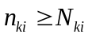, agent i will be charged a discount price (p_{ki}) by platform k. For simplification and visualization purposes, suppose that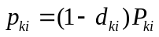, where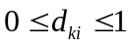is the discount rate. Specifically, d_{ki}=1 implies a free charge strategy for agent i who participates in platform k; d_{ki}=0 indicates that there is no price discrimination and the benchmark price is the discount price. If agents on both sides are imposed with a price discrimination strategy the results will become vague and complicated, so the assumption is made that only agent A encounters the price discrimination executed by the platforms and that agent B can always guarantee the demand coming from agent A despite the number of transaction times.
To further simplify the results, the following assumptions were also made 1) v_{i} is high enough that the agents markets are covered completely. This will ensure that platforms are not a local monopoly and will compete for the two groups of agents under the standard Hotelling model conditions. 2) t_{i}>θ_{i}. This assumption implies that production differentiation is stronger than average across network externality, despite being within groups or across groups (Armstrong, 2006a). This fact will also rule out the possibility of corner solutions, which occurs when all of the agents choose the same platform independently of their location. For saving variables, let t_{A}=t_{B}=t and θ_{A}=θ_{B}=θ. 3) N₁>N₂. There are three cases N_{1A}>N_{2A}, N_{1A}<N_{2A}, and N_{1A}=N_{2A}, given that the two platforms make their own price discrimination threshold both independently and simultaneously. N_{1A}=N_{2A} is a special situation of the other two cases, and N_{1A}>N_{2A} is the same as N_{1A}<N_{2A}due to the symmetric assumption previously mentioned, which is that there is no fixed cost and no marginal cost. Thus, N_{1A}>N_{2A} is the typical case found in this model and can be simplified to N₁>N₂. 4) Both platforms and agents pursue short-term profits or utilities, which implies that every platform maximizes profits from the sum of every transaction and no agent is given a special preference on either platform.
The game process unfolds as described: in stage 0, both platforms choose a price discrimination strategy to overcome the “chicken and eggs problem”; in stage 1, both platform 1 and 2 simultaneously decide their benchmark prices, given that both the discount rate and the price discrimination threshold are exogenous; in stage 2, agents choose either platform 1or 2 based upon the principle of maximum utility.

4. The analysis
Each agent in both groups observes all of the entrance prices before they decide which platform to join. The number of agents who join a platform is given by the Hotelling specification (Caillaud and Jullien, 2003; Armstrong, 2006a). The location of the marginal agent i, who is indifferent between platform 1 and 2 is given by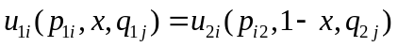, in which x is the distance between marginal agent i and platform 1, and is also referred to as the actual number of agents who choose platform 1, until this is satisfied the adjustment will continue until the marginal agent i receives the same utility in both platforms. Given that the platforms set different price thresholds, the following should be satisfied when equilibrium is reached:
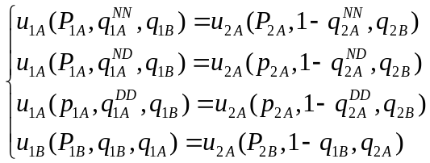 (1)
where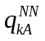, 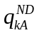, 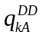is the demand of agent A who participates in platform k when n_{kA}<N₂, N₂< n_{kA}<N₁, n_{kA} >N₁, respectively.
The total demand of agent A participating in platform k will then be
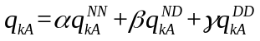 (2)
where α, β, γ is the uniform probability destiny of agent A when n_{kA}<N₂, N₂<n_{kA}<N₁, n_{kA}>N₁ and also satisfies α+β+γ=1. In other words, α represents the scenario in which there is no price discrimination being imposed upon agent A by the two platforms; β represents the scenario in which only a price discrimination from platform 2 and no price discrimination from platform 1 is being imposed upon agent A; γ represents the scenario in which both platforms are simultaneously imposing price discrimination on agent A. A larger N₂ means a bigger α, resulting in a smaller number of agent As that will enjoy a price discrimination strategy made by both platforms; a larger threshold gap N₁-N₂ means a bigger β, resulting in an increase in the difference between the two platforms; a larger N₁ means a smaller γ, resulting in fewer agent As that will face a price discrimination strategy imposed by platform 1.
The profit functions of platform 1 and 2 respectively are given by,
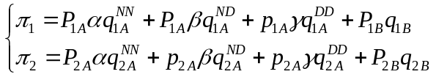 (3)
In order to derive the optimal entrance prices for each platform, we substitute (2) into the profit functions (3) and consider the first partial derivative of π_{k} with respect to P_{ki}. The high number of variables leads to extremely complex results so here we attempt to study the impact of the price discrimination strategy executed by two-sided platforms from three special scenarios based on the previously described framework.
4.1 Scenario 1: α=0
In this scenario, when α=0 this indicates that β+γ=1, that is, platform 2 executes a price discrimination strategy to each agent A, while platform 1 aims at only a partial agent A whose transaction time exceeds the price discrimination threshold N₁. The main research question being addressed here is to determine the effectiveness of the price discrimination strategy in the benefit all agents.

Proposition1. Given α=0, the equilibrium benchmark prices for each group of agents made by platform k are
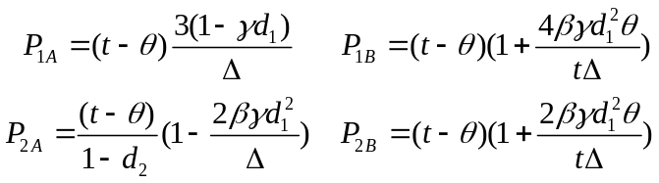 (4)
the equilibrium market shares are
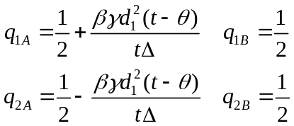 (5)
and the equilibrium profit of each platform is
(6)
where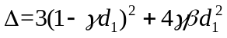.

From proposition 1, one can make the following observations,
- P_{2A} is increasing with d₂, while the other equilibrium benchmark prices, P_{1A} and P_{kB}, are completely independent from d₂, so are the equilibrium market shares and profits.
- P_{1B}>P_{2B} and P_{1A}>p_{2A}>p_{1A}, however, the relation between P_{1A} and P_{2A} is unclear.
- Despite the relation between d₁ and d₂ is, we obtain q_{1A}>q_{2A} and q_{1B}=q_{2B}.
- π₂>π₁. q_{1A}>q_{2A}
Proof 2) 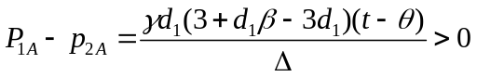and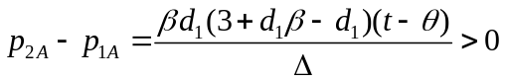.
The interpretation of the price discrimination strategy is straightforward, which is that d₁ plays an important role in P_{ki}, q_{kA} and π_{k}, as shown in equations (4), (5) and (6). In a sense, the first observation that the price discrimination strategy as executed by platform 2 is a fraudulent act is an intuitive fact because as platform 2, with a discount rate of d_{2,} increases the benchmark price up to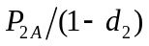eventually results in agent A being charged the same actual price as if there were no price discrimination. Additionally, the conclusion can be made that a full price discrimination strategy should not be trusted by any agent A, resulting in the failure of platform 2 to attract more agents, as shown in the first part of observation 3. The second observation implies that despite what the price discrimination thresholds and discount rates are, in comparison to platform 2, platform 1 will always make a higher benchmark equilibrium price for agent B; the discriminative price being charged to agent A by platform 2 is higher than that in platform 1, however it is lower than the benchmark equilibrium price of platform 1. This also demonstrates that platform 2 with a full price discrimination strategy is fraudulent behavior. The third observation indicates that the price discrimination strategy only works on agent A’s market shares and has no effect on agent B’s. Platform 1 obtains more agent As than platform 2, however agent B’s market is divided equally. The fourth observation is what is typically expected. That is, the full price discrimination strategy is better than the partial price discrimination strategy from the view of a two-sided platform; this is due to P_{2A} being the dominant variable and more important than P_{2B}, q_{2A} and q_{2B}. This could potentially explain why the full price discrimination strategy is a common practice and why so many companies always declare that anyone who participates in them will enjoy a promotion price. Ironically, this is just an illusion.
Especially, if d₁=d₂=0, then no price discrimination is imposed, the equilibrium results are P_{ki}=t-θ and q_{ki}=0.5 and π_{k}=t-θ. This conclusion is the same as conclusions drawn in Armstrong (2006a) and Rochet and Tirole (2004). Equilibrium prices depend in a positive manner on the differentiation parameter t and negatively on the strength of the cross network externality θ, and the agent’s market shares and platform’s profit are divided equally.

Corollary1. Based on Proposition 1, the following is true
- q_{2βA}>q_{1βA} and q_{2γA}<q_{1γA}
- π_{2A}>π_{1A} and π_{2B}<π_{1B}.
- If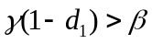, π₁ and π₂ decreases with β while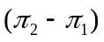increases with β.
- π₁ and π₂ represent the decreasing function of d₁ whereasrepresents the increasing function of d₁.
Proof. Due to the complex nature of the initial expression of the results, the details regarding the expression of q_{kβA}, q_{kγA}, π_{ki} are omitted and only the comparison results are shown. The conclusion from the Corollary 1 can easily be drawn from the following results.
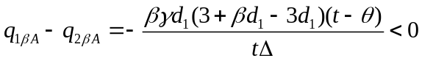, 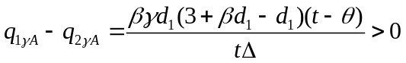
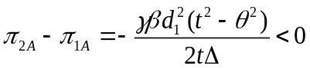,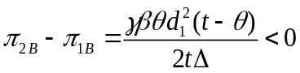, and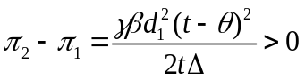.

The first result shows that more agent As choose platform 1 when they face a discriminative price imposed by the two platforms simultaneously. Combining this result with proposition 1(3), we can conclude that platform 1 should set a discriminative price if platform 2 chooses a full price discrimination strategy. The reason being that platform 1 attracts more agent As, both in target agent As and total agent As, than platform 2. The second result shows that platform 2 receives more profits from agent B’s market, however fewer profits from agent A’s market. The third result implies that platform 2 has a competitive advantage. Given a fixed discount rate and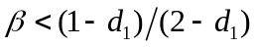, the larger the β means a larger N₁, which is bad for both of the two platforms however is worse for platform 1. The disadvantageous position of platform 1 in this situation improves when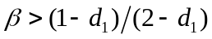however its profit is still less than the profit of platform 2. This implies that platform 1 should set a high price discrimination threshold when platform 2 chooses a full price discrimination strategy, given a fixed discount rate. The first part of the fourth result is similar to commonly drawn conclusions for a one-sided market, that is, that price discrimination transfers the partial platform’s profit to consumers. The second part of the fourth result implies that a larger d₁ puts platform 1 at a disadvantage when compared with platform 2, which is the same as the third result. Therefore, choosing a smaller d₁ is an optimal strategy for platform 1 when its competitor chooses to implement a full price discrimination strategy.
The comparative statistics for the parameters of β and d₁ as well as the other equilibrium variables are presented in Table 1.
Table 1 Comparative statics for the scenario where α=0
 | P |  |  |  |  |  | q
 | Platform 1 |  |  | Platform 2 |  |  | Platform 1 |  |  | Platform 2
 | P_{1A} | p_{1A} | P_{1B} | P_{2A} | p_{2A} | P_{2B} | q_{1βA} | q_{1γA} | q_{1A} | q_{2βA} | q_{2γA} | q_{2A}
β | ↑** | ↑** | ↑* | ↓* | ↓* | ↑* | ↑ | ↓ | ↑* | ↓ | ↑ | ↓*
d₁ | ↑*** | ↓ | ↑ | ↓ | ↓ | ↑ | ↑**** | ↑ | ↑ | ↓**** | ↓ | ↓
Note: ↓ decrease; ↑ increase; *;**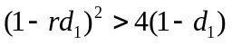;***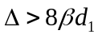;****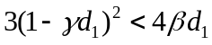

Here, a numerical example is given in order to show other detailed findings not displayed in Proposition 1 and Corollary 1. Let t=1.2, θ=0.5 and d₂ =0.3, the illusive results are shown in Fig. 1.
[Insert Figure 1 here]

Fig. 1 Impacts of β (when d₁ =0.4) or d₁ (when β=0.4) on equilibrium prices, market shares and profits

The comparative statistics of the equilibrium prices with respect to β and d₁ are shown in Fig. 1 (a) and Fig. 1 (d) and the following observation can be made. First, P_{1A} and p_{1A} decrease in β when β<0.87 and increase in β when β>0.87; P_{1A} decreases in d₁ when d₁>0.5 and increases in d₁ when d₁<0.5; the rest of the variables are in accordance with Table 1. Second, p_{2A}-p_{1A} increases in β, however P_{2A}-P_{1A} only increases in β if β>0.19 and decreases in β if β<0.19. Third, despite the value of β and d₁, discriminative prices are less than the equilibrium prices in the case where there is no price discrimination.
The comparative statistics of the equilibrium market shares of platform 1 in agent A’s market with respect to β and d₁, are shown in Fig. 1 (b) and Fig. 1 (e), and we observe that q_{1A} increases in β if β<0.375 and decreases in β if β>0.375; q_{1βA} increases in d₁ if d₁<0.67 and increases in d₁ if d₁>0.67; the rest of the variables are also consistent with our findings for Proposition 1 and Corollary 1 and Table 1. The market shares figures for platform 2 are ignored because they are the reverse of the ones shown in Fig. 1 (b) and Fig. 1 (e) for platform 1.

4.2 Scenario 2: β=0
In this scenario, when β=0 this indicates that α+γ=1, that is, platform 1 and 2 have set the same price discrimination threshold and compete for a part of agent A whose transaction time exceeds the watershed. The only difference between the platforms is the discount rate. The main question being addressed is whether or not a high discount rate can attract more agents and increase profits. A larger number of independent variables leads to complex results, so proposition 2 only provides the difference of the relative variables shown below:

Proposition2. Give β=0, the difference between the benchmark equilibrium prices of the two platforms are
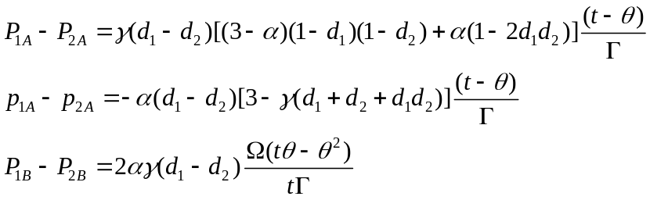 (7)
the difference in the equilibrium market shares are
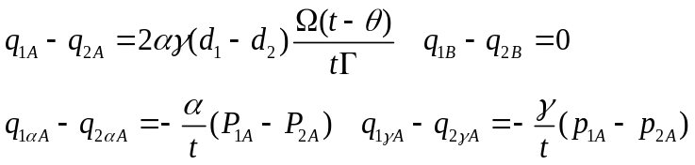 (8)
and the difference in the profits between two platforms are
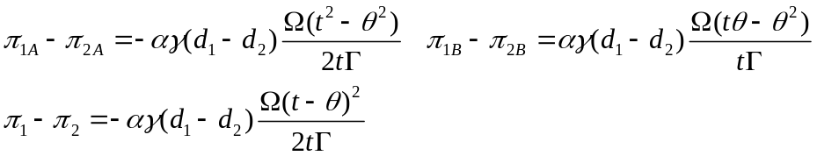 (9)
where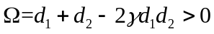and.

The following observations can be drawn from proposition 2,
- The relation between P_{1A} and P_{2A} is dependent upon d₁ and d₂ and α, and q_{1αA} and q_{2αA} are as well.
- Despite the relation between d₁ and d₂, q_{1B}=q_{2B}.
- p_{1A}<p_{2A}, P_{1B} >P_{2B}, q_{1A}>q_{2A}, q_{1γA}>q_{2γA}, π_{1A}<π_{2A}, π_{1B}>π_{2B} and π₁<π₂ if d₁>d₂.
The first observation implies that a larger price discount cannot ensure a larger benchmark equilibrium price in agent A’s market because α also plays an important role in equilibrium. P_{1A}>P_{2A} is satisfied ifand d₁>d₂. q_{1αA} and q_{2αA} also have a similar result. The second observation shows that two platforms also equally share agent B’s market, the same as in scenario 1 where α=0. The third observation indicates that platform 1, when it has a higher discount rate, can attract more agents A and receive a higher price and an increase in the profit from agent B’s markets, however it receives far less profit from agent A’s market as compared with the total profits from platform 2. That is, a platform with higher discount rate only attracts more participating agents. Thus, a platform can extend its market share by setting a higher discount rate when its opponent also chooses to use a price discrimination strategy. Additionally, the third observation proves that a larger discount rate leads to a smaller discriminative price, which is in accordance with the real phenomenon found in reality.
If d₁=d₂, i.e., then two platforms set the same discount rates and we have the following:
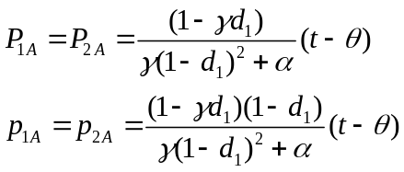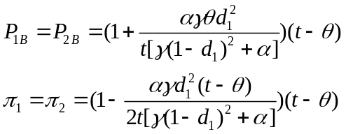
We get P_{kA}>t-θ, P_{kB}>t-θ, p_{kA}<t-θ, q_{ki}=0.5and π_{k}<t-θ. Both platforms set higher benchmark prices, however obtain fewer profits. The only winner is the partial of agent A whose transaction times exceeds the threshold because they can enjoy a low discriminative price. In other words, a price discrimination strategy is a complete failure in this situation as compared to a situation with no price discrimination.
The same numerical example is given to show some other detailed findings, t=1.2 and θ=0.5, and the illusive results are shown in Fig. 2. The analyses of the comparative statistics of the variables with respect to d₂ were omitted due to the symmetric structure in this scenario.
[Insert Figure 2 here]
Fig. 2 Impacts of α (when d₁=0.4; d₂=0.2) or d₁ (with α=0.4 and d₂ =0.4) on equilibrium prices, market shares and profits

The comparative statistics of the equilibrium prices with respect to α and d₁ are shown in Fig. 2 (a) and Fig. 2 (d), and several observations are noted. First, both P_{kA} and p_{kA} decrease in α when d₁>d₂, but first they increase and then decrease following an increase of d₁. Second, P_{1A}-P_{2A} decreases in α while p_{2A}-p_{1A} increases in α if d₁>d₂; P_{2A}-P_{1A} and p_{2A}-p_{1A} decrease in d₁ if d₁<d₂; p_{2A}-p_{1A} is increasing in d₁ if d₁>d₂, but P_{2A}-P_{1A} first increase in d₁ and then decrease in d₁ if d₁>d₂; Third, despite the value of α, P_{kA}>t-θ and p_{kA}<t-θ. However, the same observation in Fig. 2 (d) cannot be obtained.
The comparative statistics of the equilibrium market shares of platform 1 in agent A’s market with respect to α and d₁ are shown in Fig. 2 (b) and Fig. 2 (e), and we observe that q_{1A} is increasing in α if α<0.36 and increasing in α if α>0.36; q_{1αA} increases in α, but q_{1γA} decreases in α; q_{1A} and q_{1γA} increase in d₁, but q_{1αA} decreases in d₁ if d₁<0.75 and increases in d₁ if d₁>0.75. Second, q_{1αA}<q_{2αA} and q_{1γA}>q_{2γA} are always satisfied if d₁>d₂, despite the value of α. Third, the opposite result can also be drawn for the market shares of platform 2.
For the comparative statistics of the equilibrium profits, with respect to α and d₁, it can be observed that π_{k}, π_{kA} and π_{kB} are not monotonous functions, such as the scenario when α=0.

4.3 Scenario 3: γ=0
In this scenario, when γ=0 this indicates that α+β=1, which indicates that the price discrimination strategy to partial agent A whose transaction time exceeds the threshold is only being executed by platform 2, while platform 1 chooses not to use any price discrimination strategy. Here we address the issue of whether or not it is more beneficial to use of a price discrimination strategy.

Proposition3. Given γ=0, the equilibrium benchmark prices for each group of agents made by platform k are given as follows:
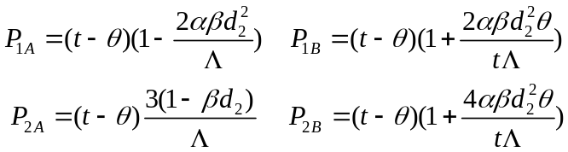 (10)
the equilibrium market shares are:
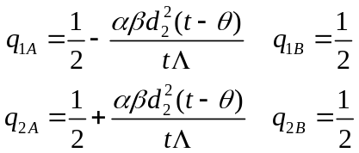 (11)
and the profit of each platform is:
(12)
where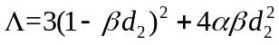.

The following observations can be drawn from proposition 3:
- p_{2A}< P_{1A}<P_{2A} and P_{1B}<P_{2B}.
- Despite the value of d₂, q_{1A}<q_{2A} and q_{1B}=q_{2B}.
- π₁>π₂.
The first observation indicates that platform 2 sets higher benchmark equilibrium prices than platform 1. However, the discriminative price for those whose transaction time exceeds the threshold in platform 2 is lower than the benchmark equilibrium price of platform 1. Additionally, when comparing to the equilibrium prices in the case with no price discrimination, then P_{2A} >t-θ, P_{kB}>t-θ and P_{1A}<t-θ, p_{2A}<t-θ. This reveals the fact that platform 2 first raises its equilibrium prices and then gives partial agent A a discriminative price. Finally, all of the agents with the exception of the partial agent A are imposed with higher entrance prices. The reason behind P_{1A}<t-θ is the cross externality which connects the two platforms together and sends competitive signals to each other. The second observation implies that the use of a price discrimination strategy by platform 2 in an effort to attract more agents A is feasible. However, the two platforms have equal market shares in agent B’s market, such as is seen in the case of α=0 and β=0. Though platform 2 can increase their profits from agent B’s market, it will not compensate for the loss due to the price discount in agent A’s market. This results in the final profit of platform 2 being less than the profit of platform 1. Thus, we conclude that platform 2 can only attract more agents if it carries out a partial price discrimination strategy when its competitor chooses not to use any price discrimination strategy.
Especially, if α=0 and γ=0, platform 2 sets up a price discount strategy to all agents A who participate while platform 1 makes no price discrimination choice, then 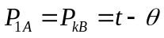, 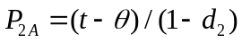and q_{ki} = 0.5 and π_{k} = t-θ. The price discount of platform 2 is a fraudulent act, as it was in scenario 1 where α=0; both platforms equally share both the market shares and the profits.

Corollary 2. Based upon Proposition 3, the following can be made
- q_{2βA}>q_{1βA} and q_{2αA}<q_{1αA}
- π_{2A}<π_{1A} and π_{2B}>π_{1B}.
- If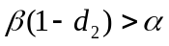, π_{kA} and π_{k} decreases with α while π_{kB} and π₁-π₂ increases with α.
- π_{kA} and π_{k} are decreasing function of d₂ while π_{kB} and π₁-π₂ are increasing function of d₂.
Proof. The conclusion of Corollary 2 can easily be determined from the following results.
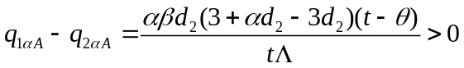, 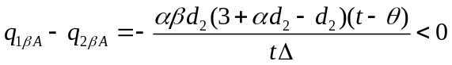
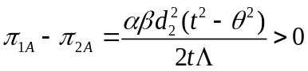,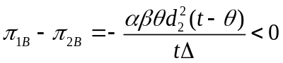, and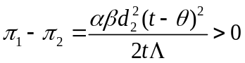.

The first result shows that more agents A choose platform 2 when they face a discriminative price imposed by only one platform. Combining this result with proposition 3(2), we can conclude that platform 1 is at a competitive disadvantage. The second result is same as Corollary 1(2). The third result implies that the profits are not monotonic functions. Given a fixed discount rate and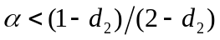, a larger α implies a larger N₂, and is bad for the two platforms, but worse for platform 2. The competitive disadvantage of platform 2 improves when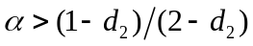however its profit is still less than the profit of platform 1. This concludes that platform 2 is at a competitive advantage and fails to maximize their profits. The first part of the fourth result is similar with Corollary 1(4). The second part of the fourth result implies that a larger d₂ puts platform 2 at a competitive disadvantage to platform 1. Therefore, choosing a smaller d₂ is an optimal strategy for platform 2 when its competitor chooses not to use a price discrimination strategy.
Additionally, the comparative statistics for the parameters of α and d₂ on the other equilibrium variables are presented in Table 2.
Table 2 Comparative statics for the scenario where γ=0
 | P |  |  |  |  | q
 | Platform 1 |  | Platform 2 |  |  | Platform 1 |  |  | Platform 2
 | P_{1A} | P_{1B} | P_{2A} | p_{2A} | P_{2B} | q_{1αA} | q_{1βA} | q_{1A} | q_{2αA} | q_{2βA} | q_{2A}
α | ↓* | ↑* | ↑** | ↑** | ↑* | ↑ | ↓ | ↓* | ↓ | ↑ | ↑*
d₂ | ↓ | ↑ | ↑*** | ↓ | ↑ | ↑**** | ↓ | ↓ | ↓**** | ↑ | ↑
Note:↓ decrease; ↑ increase; — uncertainty;*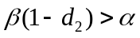; ** 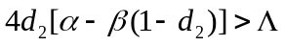;*** 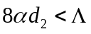;
**** 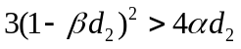;

Similarly, same numerical example is given to show other detailed findings, that is, t=1.2 and θ=0.5, and the illusive results are shown in Fig. 3.
[Insert Figure 3 here]
Fig. 3 Impacts of α (when d₂=0.4) or (when α=0.4) on equilibrium prices, market shares and profits

For the comparative statics of equilibrium prices, with respect to α and d₂, as shown in Fig. 3(a) and Fig. 3(d), the following observations can be made. First, P_{2A} and p_{2A} decrease in α, but P_{2A} decreases in d₂ if d₂>0.52 and increases in d₂ if d₁<0.52; the rest of variables are in accordance with Table 2. Second, P_{2A}-P_{1A} increases in α.
For the comparative statics of equilibrium market shares of platform 1 in agent A’s market, with respect to α and d₂, it can be observed that q_{1A} decreases in α if α<0.375 and increases in α if α>0.375 whereas q_{1αA} increases in d₂ if d₂<0.67 and decreases in d₂ if d₂>0.67.

4.4 Comparison between three scenarios
This section compares the equilibrium solutions among the three scenarios in two-sided platforms with price discrimination. The analysis reveals the following:
- A two-sided platform with a price discrimination strategy cannot simultaneously attract more agents and increase profits. The profits are greater with fewer agents A in platform 2 in scenario 1 and 2 where α=0 and β=0 (if d₁>d₂), the opposite is true in scenario 3 where γ=0.
- A lower price discrimination threshold does not ensure bigger markets shares due to a non-monotonic function, as shown in Fig. 1(b), Fig. 2(b) and Fig. 3(b), so are the total profits, as shown in Fig. 1(c), Fig. 2(c) and Fig. 3(c). Platform 1 receives the biggest market share of agent A when β=0.375 in scenario 1 where α=0 and α=0.36 in scenario 2 where β=0, and the smallest market share of agent A when α=0.375 in scenario 3 where γ=0.
- A larger discount rate is bad for the profit of a platform, however is good for its market share, as shown in Fig. 2(f), Fig. 3(f) and Fig. 2(e), Fig. 3(e). To a certain extent, this conclusion is also correct in scenario 1 where α=0, because π₂>π₁ and q_{1A}>q_{2A} always holds despite the relation between d₂ and d₁. In other words, a larger discount rate is an effective way to overcome the “chicken and eggs” problem.
- The best response strategy for a platform aiming at maximizing profit is also to remain intact when its opponent chooses a price discrimination strategy; otherwise it receives a smaller profit despite what the discount rates are. Additionally, the equilibrium profits are less than those without a price discrimination strategy.

5. Concluding remarks
This paper analyzes a price discrimination strategy model in duopolistic single-homing two-sided platforms; a research area that has previously received little attention. Theoretically, we extend a recent duopolistic model proposed initially by Rochet and Tirole (2006) and Armstrong (2006a) and Liu Serfes (2008) and incorporate a price discrimination strategy. Using the feedback solutions from dynamic game theory, the optimal prices, market shares and profits for three different scenarios are obtained and the comparative statistics for the different factors based on different aims are presented.
The analysis clearly indicates that no agent should trust a full price discrimination strategy in a two-sided platform and that this will also result in the failure of the platform to attract more agents. Agents whose transaction times exceed the price discrimination threshold can reap the benefits from price discrimination made by a two-sided platform, however the rest are at a disadvantage because they are charged with high benchmark equilibrium prices. Two-sided platforms with a price discrimination strategy cannot simultaneously attract more agents and increase their profits, and therefore the best response strategy for a platform aiming at maximizing their profit is to maintain their price discrimination strategy when their opponent chooses to use a price discrimination strategy, otherwise they will receive a smaller profit despite what the discount rates are. A low price discrimination threshold, a situation in which more agents are enjoying the price discrimination strategy, cannot ensure bigger markets shares because of the non-monotonic function, however a large discount rate is bad for a platform from the perspective of both the market share and the profit.
The overall importance and the managerial implications of our results are somewhat limited due to the simplification of the assumptions in the model. Future research should be extended to encompass a price discrimination strategy on both sides of a two-sided platform. Using the visa card as an example, users and merchant are simultaneously confronted with the issue of price discrimination imposed by the visa card, however the foundation is different. The former usually is the total value of transactions while the latter is typically the transaction times. Future should also focus on the long-term perspective, which may address the issue of why the price discrimination strategy cannot be executed for a long time. Additionally, future efforts will determine whether it is a solution to “chicken and eggs” problem or an effective strategy to gain an advantageous position in competition once the dynamic growth path of a two-sided market is described.

Acknowledgement
The authors are the only persons responsible for the remaining errors. Additionally, this work is supported in part by Natural Science Foundation of China (71102173), China Postdoctoral Science Foundation Funded Project (2013M530890) and China Postdoctoral Science Special Foundation (2014T70232) and Program for the Outstanding Innovative Teams of Higher Learning Institutions of Shanxi (2015052005) and the Scientific Research Foundation for the Returned Overseas Chinese Scholars, Shanxi.

References
Armstrong, M., 2006a. Competition in two-sided markets. RAND Journal of Economics, 37(3):668-691.
Armstrong, M., 2006b. Recent developments in the economics of price discrimination. Chapter 4 in Advances in Economics and Econometrics. PP.97-141. Cambridge University Press.
Armstrong, M., Wright, J., 2007. Two-sided markets, competitive bottlenecks and exclusive contracts. Economic theory, 32(2):353-380.
Baxter, W.F., 1983. Bank exchange of transactional paper: Legal and economic perspectives. Journal of Law and Economics, 26(3):541-588.
Caillaud, B., Jullien, B., 2003. Chicken & egg: competition among intermediation service providers. RAND Journal of Economics, 34(2):309-328.
Chakravorti, S., Roson, R., 2006. Platform competition in two-sided markets: The case of payment networks. Review of Network economics, 5(1):118-142.
Chen, K., Tse, E., 2007. Dynamic platform competition in two-sided markets. Working paper, Stanford University. < http://papers.ssrn.com/sol3/papers.cfm?abstract_id=1095124 >.
David, P.A., 1985. Clio and the economics of QWERTY. American Economic Review, 75(2):332-336.
Doganoglu, T., Wright, J., 2006. Multi-homing and compatibility. International Journal of Organization, 24(1): 45-67.
Economides, N., 2008. “Net neutrality,” non-discrimination and digital distribution of content through the internet. I/S: A Journal of Law and Policy for the Information Society, 4(2):209-233.
Economides, N., Katsamakas, E., 2006. Two-sided competition of proprietary vs. open source technology platforms and the implications for the software industry. Management Science, 52(7):1057-1071.
Eriksson, K., Sjöstrand, J., Strimling, P., 2008. Asymmetric equilibria in dynamic two-sided matching markets with independent preferences. International Journal of Game Theory, 36(3):421-440.
Farrell, J., Saloner, G., 1985. Standardization, compatibility and innovation. RAND Journal of Economics, 16(1):70-83.
Gabszewicz, J., Wauthy, X., 2004. Two-sided markets and price competition with multi-homing. Working paper, Université catholique de Louvain. http://papers.ssrn.com/sol3/papers.cfm?abstract_id=975897.
Gil, R., Riera-Crichton, D., 2011. Price discrimination and competition in two-sided markets: Evidence from the Spanish local TV industry. Working paper, Johns Hopkins Carey Business School.
< http://papers.ssrn.com/sol3/papers.cfm?abstract_id=1873231 >.
Guthrie, G., Wright, J., 2007. Competing payment schemes. The Journal of Industrial Economics, 55(1):37-67.
Hagiu, A., Lee, R.S., 2011. Exclusivity and control. Journal of Economics & Management Strategy, 20(3):679-708.
Hagiu, A., Jullien, B., 2007. Designing a two-sided platform: when to increase search costs? Working paper. <http://ideas.repec.org/p/ide/wpaper/7369.html>.
Hagiu, A., Spulber, D. 2012. First-Party content and coordination in two-sided markets. Management Science, 59(4):933-949.
Kaiser, U., Wright, J., 2005. Price structure in two-sided markets: Evidence from the magazine industry. International Journal of Industrial Organization, 24(1):1-28.
Katz, M.L., Shapiro, C., 1985. Network externalities, competition, and compatibility. American Economic Review, 75(3):424-440.
Liu, Q.H., Serfes, K., 2013. Price discrimination in two-sided markets. Journal of Economics & Management Strategy. 22(4):768-786.
Loertscher, S., 2007. Horizontally differentiated market makers. Journal of Economics & Management Strategy, 16(4):793-825.
Nocke, V., Peitz, M., 2007. Platform ownership. Journal of the European Economic Association, 5(6):1130-1160.
Pigou, A.C., 1920. The economics of welfare. London: Macmillan.
Reisinger, M., 2014. Two-part tariff competition between two-sided platforms. European Economic Review. 68:168-180.
Rochet, C., Tirole, J., 2003. Platform competition in two-sided markets. Journal of the European Economic Association, 4(6):990-1029.
Rochet, C., Tirole, J., 2004. Two-sided markets: an overview. Working paper. <http://faculty.haas.berkeley.edu/HERMALIN/rochet_tirole.pdf>
Rochet, J.C., Tirole, J., 2006. Externalities and Regulation in Card Payment Systems. Review of Network Economics, 5(1): 1-14.
Roson, R., 2005. Platform competition with endogenous multi-homing. Working paper. < http://papers.ssrn.com/Sol3/papers.cfm?abstract_id=657901 >.
Rust, J., Hall, G., 2003. Middlemen & market makers: A theory of competitive exchange. Journal of Political Economy, 111(2):353-403.
Rysman, M., 2004. Competition between networks: A study of the market for yellow pages. Review of Economic Studies, 71(2):483-512.
Schiff, A., 2003. Open and closed systems of two-sided networks. Information Economics of Policy, 15(4):425-442.
Schmalensee, R., Evans, D.S., 2007. Industrial organization of markets with two-sided platforms. Competition policy international, 3(1):151-179.
Spulber, D.F., 1996. Market macrostructure and intermediate. Journal of Economic Perspectives, 63(10):135-152.
Stole, L.A., 2003. Price Discrimination and imperfect competition. The Handbook of Industrial Organization (III).
Sun, M., Tse, E., 2007. When does the winner take all in two-sided markets? Review of Network Economics, 6(1):16-40.
Weisman, L.D., Kulick, B.R., 2010. Price discrimination, two-sided markets, and net neutrality regulation. Working paper. < http://papers.ssrn.com/sol3/papers.cfm?abstract_id=1582972 >.
Wright, J., 2004. One-sided logic in two-sided markets. Review of Network Economics, 3(1):44-64.

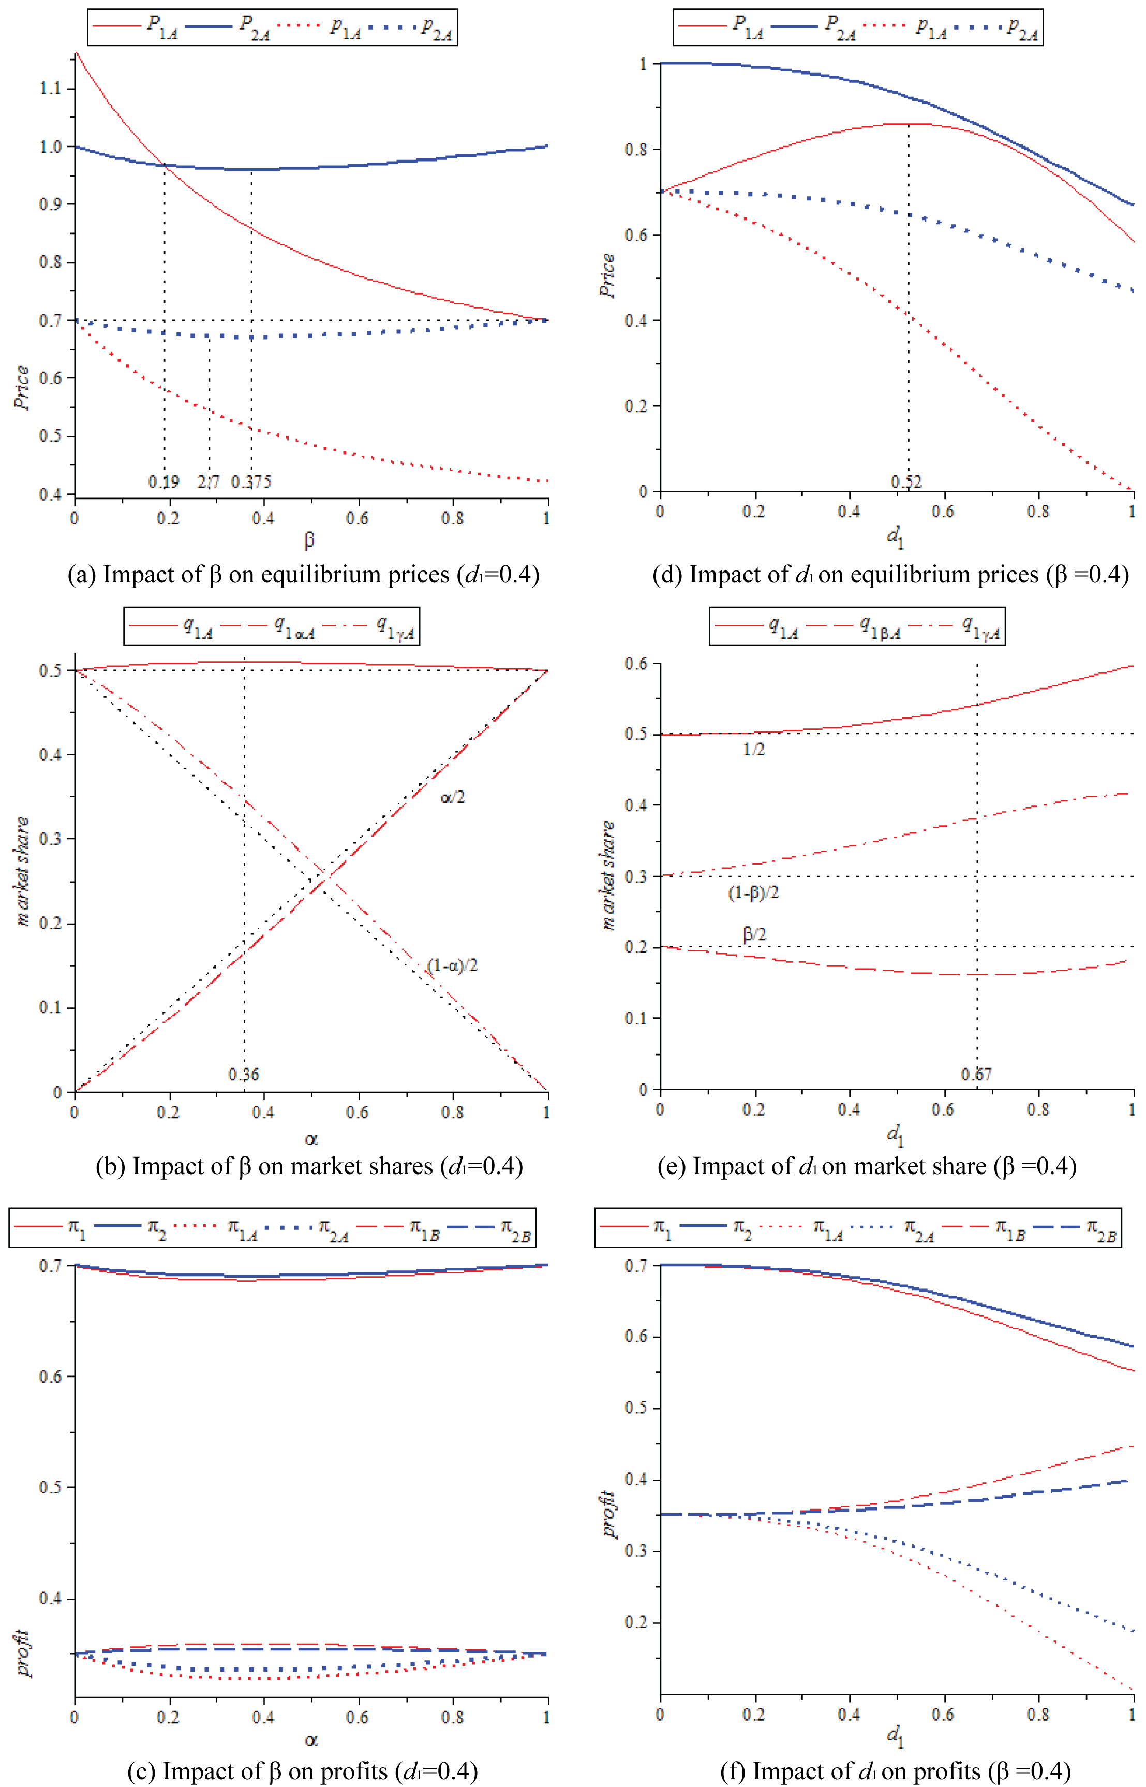
Fig. 1 Impacts of β (when d₁ =0.4) or d₁ (when β=0.4) on equilibrium prices, market shares and profits
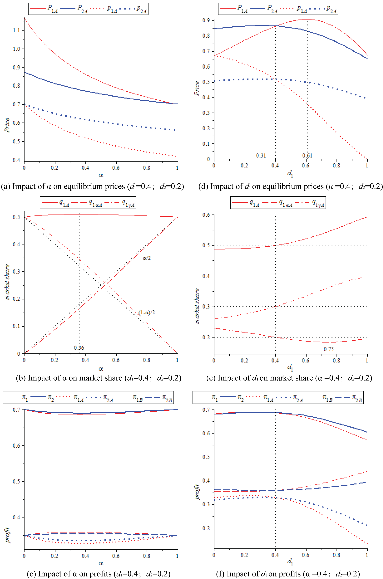
Fig. 2 Impacts of α (when d₁=0.4; d₂=0.2) or d₁ (with α=0.4 and d₂ =0.4) on equilibrium prices, market shares and profits

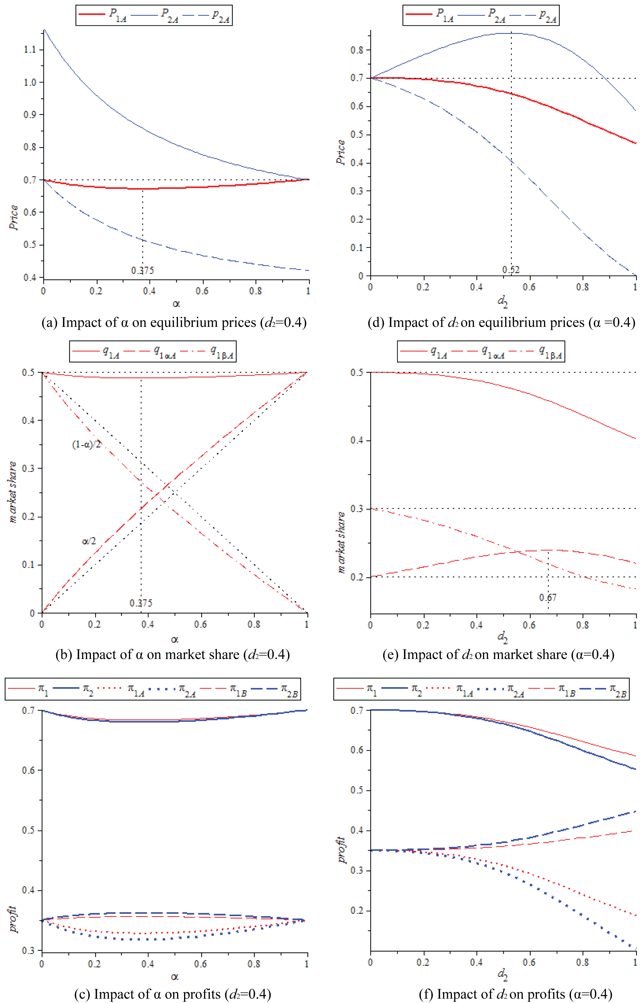
Fig. 3 Impacts of α (when d₂=0.4) or (when α=0.4) on equilibrium prices, market shares and profits

